

**INSTITUTION:** KCA University.

**UNIT NAME:** Embedded Systems.

**UNIT CODE:** BSD 3205.

**PROJECT TITLE:** Motion-activated night light.

**GROUP MEMBERS:**

Raphael Kang’eri 21/04851

Lorna Njoki 21/05092

Daniel Ted Wandegwa 21/07941

Victor Kariuki 21/03504

Washington Nabakwe 21/03952

**Declaration**

The work presented in this document is original and has not been presented at any other place.

**Introduction**

1. **Background of the Study**

A motion sensor is an electronic device that is designed to detect and measure movement. Hooking this up to a light source and you can have it activated when any kind of motion is detected.

Motion-activated night lights provide a unique solution to a variety of typical problems encountered in low-light conditions. These lights provide convenience, safety, and energy efficiency, making them an ideal alternative for bedrooms, corridors, bathrooms, and other areas where conventional lighting solutions may be problematic or unsuitable.

Existing solutions such as plug-in night lights or traditional lamps have limitations in terms of energy consumption, limited functionality, and often require manual operation. Motion-activated night lights aim to overcome these limitations by automatically illuminating when motion is detected, providing just the right amount of light needed in the environment.

1. **Problem Statement**

This project aims to address the inconvenience and inefficiency of typical night lights. Many people may find it inconvenient to manually switch on/off night lights, especially in inconvenient areas or insecure regions.

Moreover, traditional night lights may not always offer the desired level of illumination, posing safety concerns in low-light areas. This project targets individuals seeking a convenient, energy-efficient, and automated solution for nighttime illumination.

1. **Proposed System**

The proposed motion-activated night light system will consist of an Arduino UNO microcontroller, a Passive Infrared (PIR) motion sensor, LEDs, and accompanying electronics. When the PIR sensor detects motion, it instructs the Arduino to turn on the LEDs, which provide illumination for a certain amount of time. The system will be intended to be small, efficient, and easily customizable.

1. **Materials used**

The materials used in the project were:

1. Arduino board mega
2. Resistor
3. LED
4. Bread-board
5. Jumper cables
6. PIR sensor

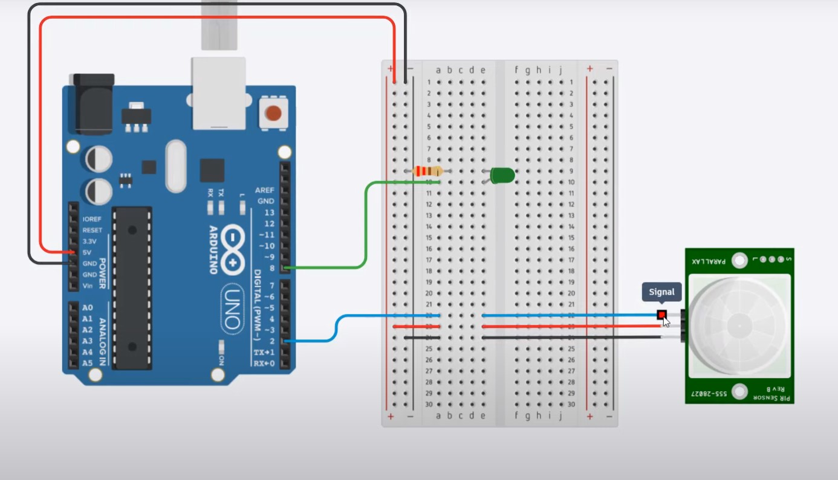

**Code**

1. const int led = 8;

2. const int pir = 2;

3. int motion;

4.

5. void setup(){

6. pinMode(led, OUTPUT);

7. pinMode(pir, INPUT);

8. }

9.

10. void loop(){

11. motion = digitalRead(pir);

12. if(motion){

13. digitalWrite(led, HIGH);

14. }

15. else{

16. digitalWrite(led, LOW);

17. }

18. }

19.

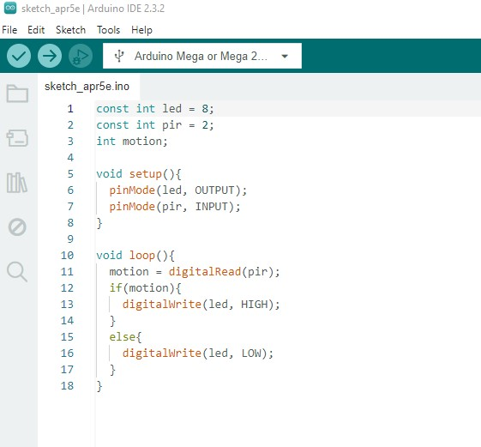

1. **Use case of the project**

**Safety and Navigation:**

* **Children's rooms:** Provide soft light for nighttime bathroom visits or reassurance in darkness without needing to turn on a main light.
* **Hallways and stairwells:** Offer gentle illumination for safe navigation in low-light areas, preventing stumbles or falls.
* **Entryways and closets:** Offer temporary light for unlocking doors, finding belongings, or navigating unfamiliar spaces at night.

**Convenience and Efficiency:**

* **Bedrooms:** Activate only when someone gets out of bed, providing light for a short period without disrupting sleep.
* **Kitchens and pantries:** Light up when someone enters for a quick drink or snack, minimizing time spent fumbling in the dark.
* **Attics and basements:** Offer temporary light for accessing infrequently used spaces without leaving main lights on.

The project is feature-complete and is ready for deployment.